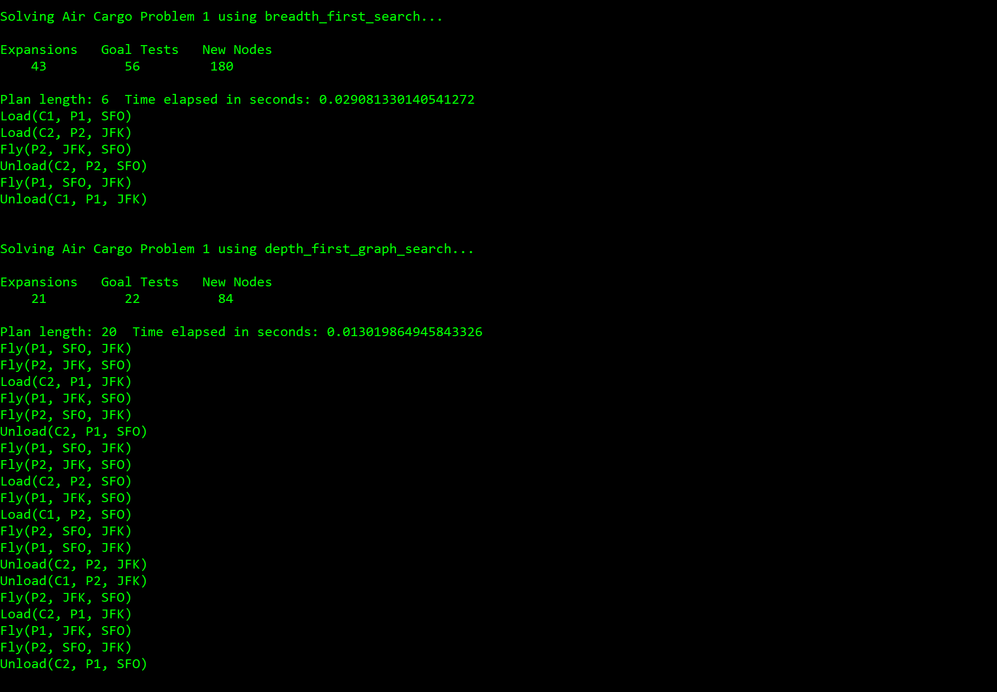

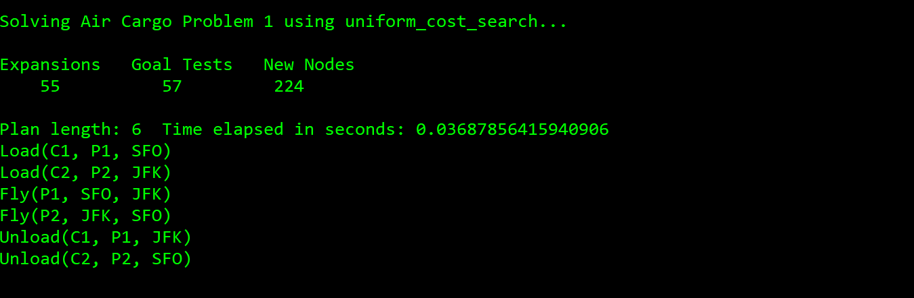

For problem 1, breadth first search expands 43 nodes, performs 56 goal tests, and completes in 0.029s. Depth first graph search expands 21 nodes, performs 22 goal tests and completes in 0.013s. Uniform cost search expands 55 nodes, performs 57 goal tests and completes in 0.036s. Depth first graph search is the optimal for problem 1.

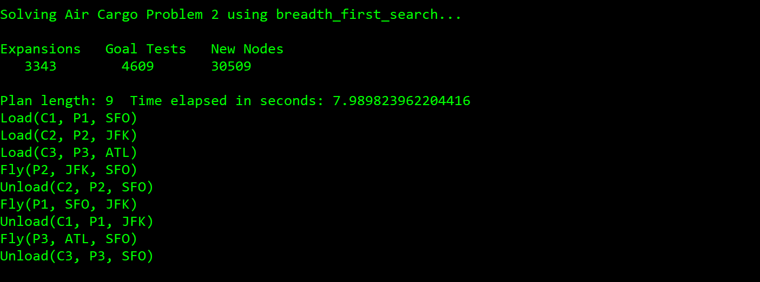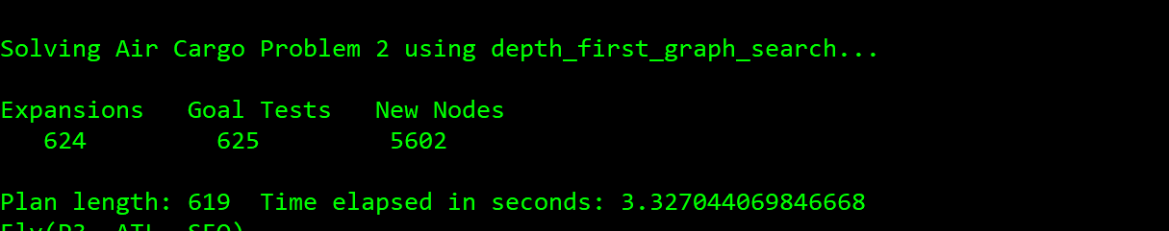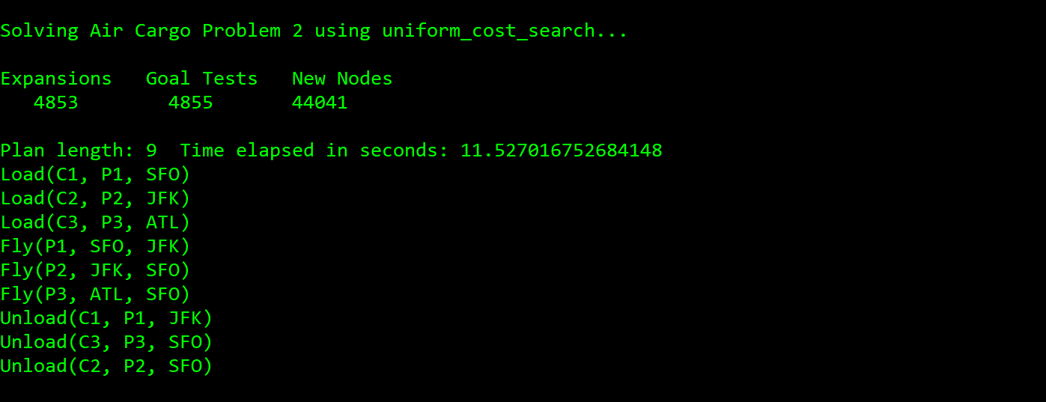

For problem 2, breadth first search expands 3343 nodes, performs 4609 goal tests, and completes in 7.990s. Depth first graph search expands 624 nodes, performs 625 goal tests and completes in 3.327s. Uniform cost search expands 4853 nodes, performs 4855 goal tests and completes in 11.527s. Depth first graph search is the optimal for problem 2.

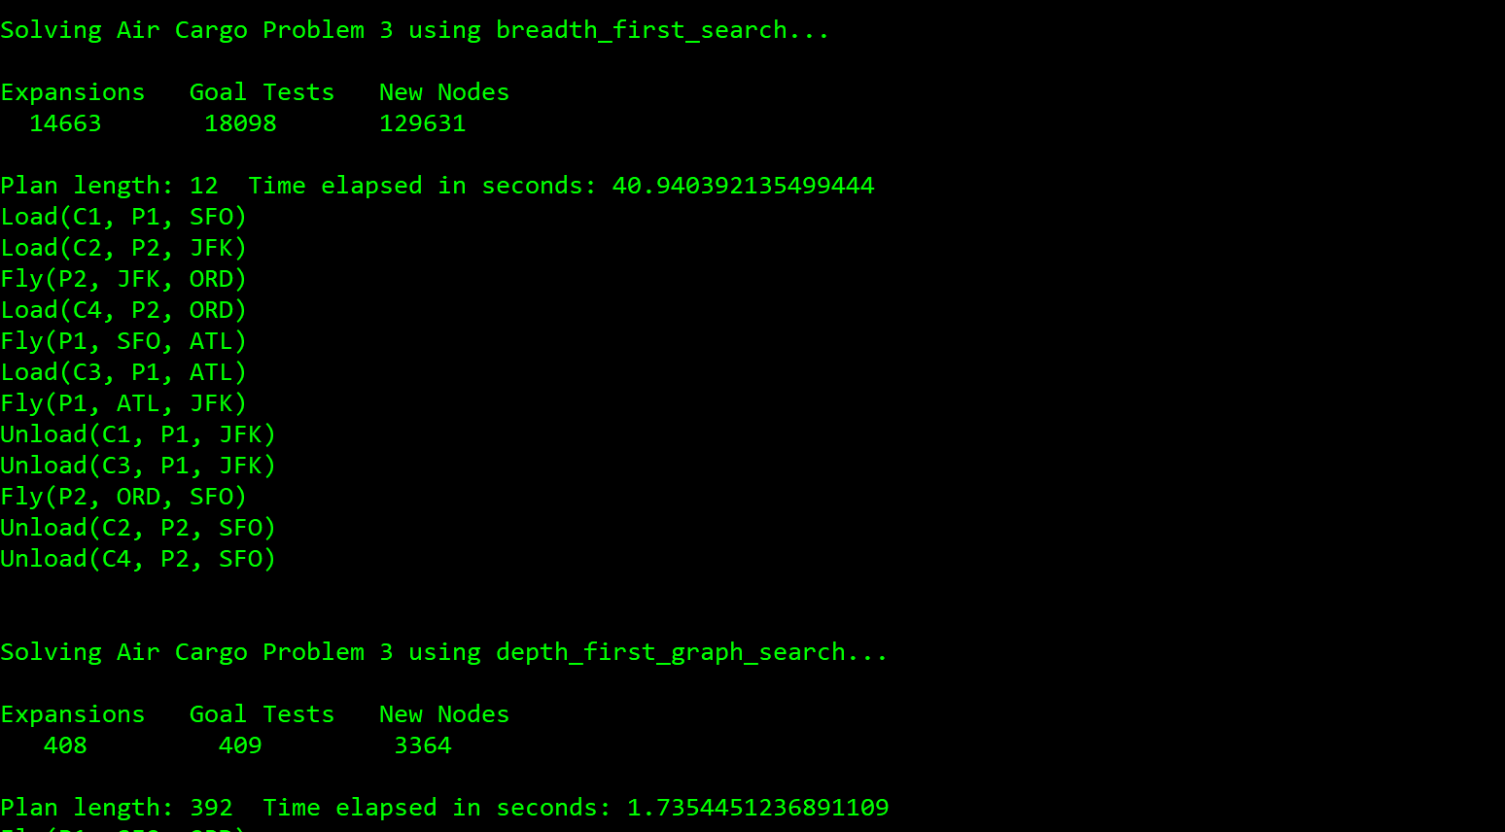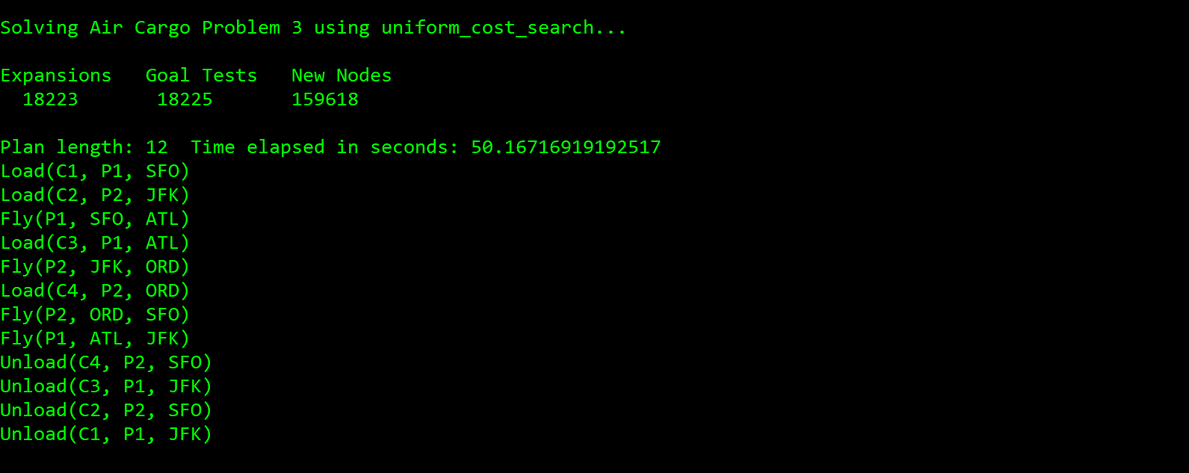

For problem 3, breadth first search expands 14663 nodes, performs 18098 goal tests, and completes in 40.940s. Depth first graph search expands 408 nodes, performs 409 goal tests and completes in 1.735s. Uniform cost search expands 18223 nodes, performs 18225 goal tests and completes in 50.167s. Depth first graph search is the optimal for problem 3.